Introduction to network security challenges:
Network security means protecting data, devices, and systems from unauthorized access and attacks.
In today’s world, networks are connected to the internet, which makes them
- Common Network Security Challenges:
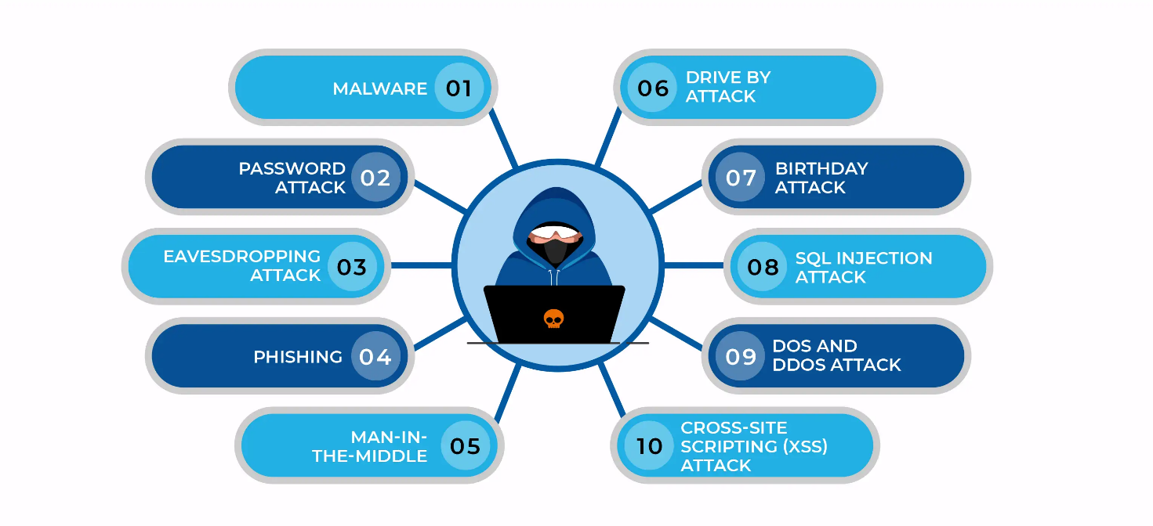
- Unauthorized Access:
- Occurs when someone enters a system without permission
- Happens due to weak passwords or poor security settings
- Attackers use methods like password guessing or brute force
- Can lead to data theft, modification, or misuse
- Affects privacy and confidentiality of users

2. Malware Attacks:
- Malware is harmful software designed to damage systems
- Includes viruses, worms, trojans, and ransomware
- Enters through infected files, downloads, or emails
- Can delete files, steal data, or control the system
3. Phishing Attacks:
- Attackers send fake emails or messages pretending to be trusted sources
- Tricks users into sharing passwords, OTPs, or personal data
- Often looks like bank or company communication
- Targets human mistakes rather than system flaws
- Can lead to identity theft or financial loss

4. Data Breaches:
- Occurs when sensitive data is exposed or stolen
- Includes personal, financial, or confidential information
- Happens due to hacking or weak security systems
- Can cause serious privacy and financial damage
- Affects both individuals and organizations

5. Denial of Service (DoS) Attacks:
- Attackers send large number of requests to a server
- Overloads the system and slows it down
- Makes services unavailable to real users
- Affects website performance and availability
- Commonly targets online services and websites

Basic Security Measures:
Security measures are designed to reduce risk by controlling access, monitoring traffic and protecting data.
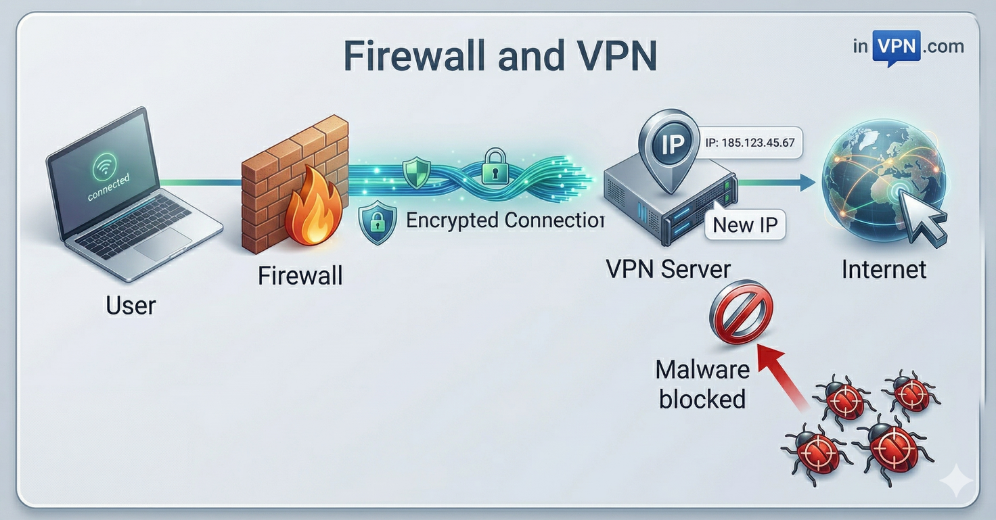
- A firewall monitors and controls incoming and outgoing network traffic.
- It blocks unauthorized access while allowing safe communication.
- Firewalls can be hardware-based or software-based.
- They act as a barrier between trusted and untrusted networks.
- Firewalls use rules to allow or deny data packets.
- A VPN (Virtual Private Network) creates a secure connection over the internet.
- VPN encrypts data, protecting it from hackers.
- It hides the user’s real IP address for privacy.
- VPN allows safe access to public Wi-Fi networks.
- Helps employees securely access office networks remotely.
- Protects sensitive data like passwords and personal information.
- Together, firewalls and VPNs provide strong network security.

